**Project Design Phase-I Solution Architecture**

|  |  |
| --- | --- |
| Date | 10 October 2022 |
| Team ID | PNT2022TMID41868 |
| Project Name | Project – IOT Enabled Smart farming application |
| Maximum Marks | 4 Marks |

**Solution Architecture:**

Solution architecture is a complex process – with many sub-processes – that bridges the gap between business problems and technology solutions. Its goals are to:

* Find the best tech solution to solve existing business problems.
* Describe the structure, characteristics, behavior, and other aspects of the software to project stakeholders.
* Define features, development phases, and solution requirements.
* Provide specifications according to which the solution is defined, managed, and delivered.

**Example - Solution Architecture Diagram:**

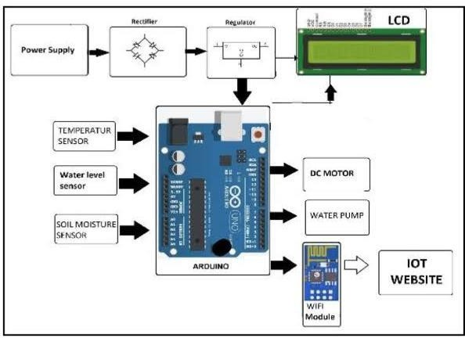

*Figure 1: IOT ENABLED SMART FARMING APPLICATION*

* The different soil parameters temperature, soil moistures and then humidity are sensed using different sensors and obtained value is stored in the ibm cloud.
* Aurdino UNO is used as a processing Unit that process the data obtained from the sensors and whether data from the weather API.
* NODE-RED is used as a programming tool to write the hardware, software and APIs. The MQTT protocol is followed for the communication.
* All the collected data are provided to the user through a mobile application that was developed using the MIT app inventor. The user could make a decision through an app, weather to water the crop or not depending upon the sensor values. By using the app they can remotely operate to the motor switch.

**Reference: https://aws.amazon.com/blogs/industries/voice-applications-in-clinical-research- powered-by-ai-on-aws-part-1-architecture-and-design-considerations/**